**traffic monitoring system**

# **DATABASE MANAGEMENT SYSTEM PROJECT**

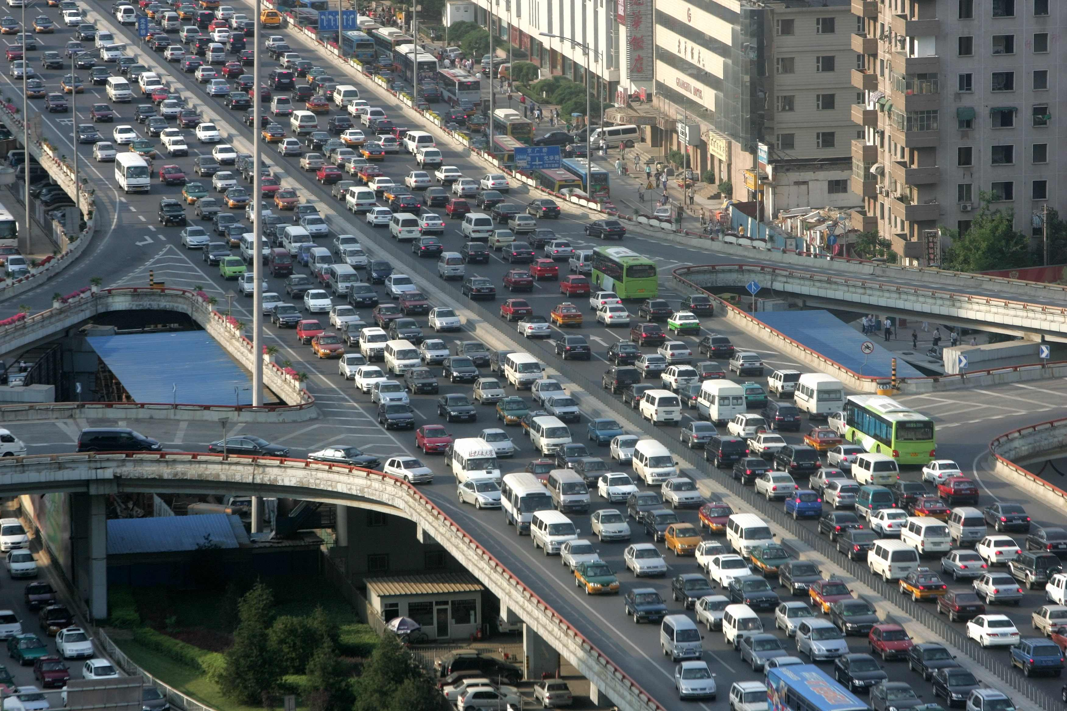

**INTRODUCTION:**

Traffic is increasing day by day because of the increasing in vehicle usage especially in urban areas.

Congestion in traffic also increases with the increase of vehicle numbers. To regulate the flow of vehicles we

are presently using traffic light controllers which have three signals. With the help of these signals we can

regulate the vehicle's direction. Most of the controllers have some fixed duration for each of the three signals

which may lead to the additional congestion in traffic. This congestion we can be avoided by two ways. One

is to design an intelligent traffic light controller which alters the duration between each signal. Other is to make

the user of the vehicle be aware of the traffic density of the path in which he is travelling. In this way different ways have been proposed to make the traffic system smarter, reliable and robust. The aim of this project is to design and develop the database for traffic monitoring system to reduce the traffic congestions and road accidents. It also maintains the records of the stolen vehicles using RFID technology.

**FUNCTIONALITIES:**

In traffic monitoring system, there are many factors under consideration like vehicle type (Emergency vehicle, Ordinary vehicles, stolen vehicles), types of roads (highways, roads under construction, normal roads) by knowing details like road id, town and junction ID. We are also provided with the details of traffic on day to day basis for each road. According to the report details, the user can choose best possible route which has less traffic congestion. Based on the history details, this system develops timeslot functionality which suggests the user to travel TO and FRO based on the time stamp. We have signaling functionalities which helps the traffic police to give signals based on timestamp for each and every road. It also provides the details of Fine summary for all types of vehicles to traffic police. We are also provided with traffic police id, name, station id of every police so that we can contact the nearest traffic police. Also, this system is provided with stolen vehicles details, as the RFID reader reads the RFID tag, it compares it to the list of stolen RFID’s. If a match is found, it sends SMS to the police station and changes the traffic light to red, so that the vehicle is made to stop in the traffic junction and local traffic police can take appropriate action. Here each vehicle is equipped with RFID tag. When it comes of range of RFID reader it sends the signal to RFID reader. The RFID reader will keep track of how many vehicles had passed through for a specific period and determine the congestion volume. Accordingly, it sets the green light duration for that path.

**MODULES:**

This system includes the following modules

* Interface creation for traffic monitoring system
* For suggesting alternate routes for emergency vehicles and during traffic congestion
* For planning city development
* Helping traffic police for signaling
* Maintaining history details
* For detection of accidents
* Maintaining the details of roads under construction
* Preparing fine summary.
* Maintain the RFID details
* Report generation.

**BENEFITS:**

This system supports traffic management, traffic police and users by providing them necessary information. It reduces the traffic congestions and road accidents. It also maintains the records of the stolen vehicles on roads.

**Name of the Team: Destined Developers**

|  |  |  |  |
| --- | --- | --- | --- |
| **Sno** | **RollNo** | **Name** | **Role**  **(Project leader, Designer, Developer, Test & Document)** |
| 1 | 17009 | ARVIND KUMAR | DEVELOPER |
| 2 | 17014 | CH S P JASWANTH | PROJECT LEADER |
| 3 | 17024 | GUHAN RAM M | TEST AND DOCUMENT |
| 4 | 17037 | MAHESH G | DESIGNER |

**Development Platform:**

* For Database - SQL
* For User Interface - WEB PAGE

**Approved By:**

**Signature of Class Handling Faculty:**